The Scientific Process
Shaquire Dean
10th September 2021

Lab Activity
A student is interested in designing several experiments to test the factors that affect how quickly an Alka-Seltzer® tablet dissolves in water (solution rate). For each question, write an appropriate hypothesis that could be tested with an experiment. Be sure to follow each hypothesis with the appropriate prediction ‘if… then… because…’ statement.
Part 1
1. Question: What effect does the water temperature have on solution rate?
Hypothesis:
Increased temperatures increases solution rate of dissolving.
Prediction:
If the tablet is placed inside warm water, then the table will be able to dissolve more faster because high temperature speeds dissolving rate of the tablet.
2. Question: What effect does crushing the tablet have on solution rate?
Hypothesis:
Crushing tablet increases solution rate
Prediction:
If the tablet is crushed, then it will dissolve faster because its particles are a combination of small pieces of the same particle.
Part 2
Experimental Design.
Select one of the questions from Part 1 above to test the effect of one variable on the solution rate of Alka-Seltzer®. Apply the steps of the Scientific Method to test the validity of your hypothesis. Once the plan is complete, follow the steps to conduct the experiment.
Question: What effect does the water temperature have on solution rate?
Hypothesis: Increased temperatures increases solution rate of dissolving.
Prediction: If the tablet is placed inside warm water, then the table will be able to dissolve more faster because high temperature speeds dissolving rate of the tablet.

Design your experiment. Determine your variables:
What is the independent variable (the variable YOU will change)?
Temperature
What is the dependent variable (the variable YOU will measure as a result of the change)?
Speed/Rate at which the tablet dissolves
List 2-3 standard variables (Variable that must be kept constant for this to be considered a “controlled experiment”.
Amount of the solution
Source of Heat
Shape of the container used.
Experimental group and the Control group:
Experimental group – The group that will be put to test.
In the effect of water temperature experiment, we can set up three uniform beakers having same amount of water at room temperatures, cold and hot; we can have timer and a thermometer. The thermometer will be useful in measuring change in water temperatures
Control group – The group that will used for comparison.
Cold, Hot and water at room temperatures.
Positive Control – Set up will be same, stirrer will be used at the highest setting.
Negative control – Set up will be the same; stirrer will not be used at all. The Alka-Seltzer® will be left to dissolve completely on its own without any assistance.
Procedure.
1. Fill one cup halfway with water and put it in the fridge for at least 10 minutes. This is your cold water.
2. Fill another cup halfway with water and leave it on the counter to get it to room temperature.
3. Use the hottest tap water and fill a third cup halfway with water. This is your hot water.
4. Use the hottest tap water and fill a third cup halfway with water. This is your hot water.
5. We begin with the hot water. Get timer ready as we drop the Alka Seltzer tablet in to the hot water. We record how long the reaction takes.
6. We now repeat step five above for the cold water and the water at room temperatures.

Create a data table to show your results.
 | Temperature | Time taken to dissolve(Minutes)
Cold water | 10 °C | 15
Water at room Temperature | 20 °C | 8
Hot water | 50 °C | 3

Graph your data. Use the data that you have collected to create an appropriate graph.
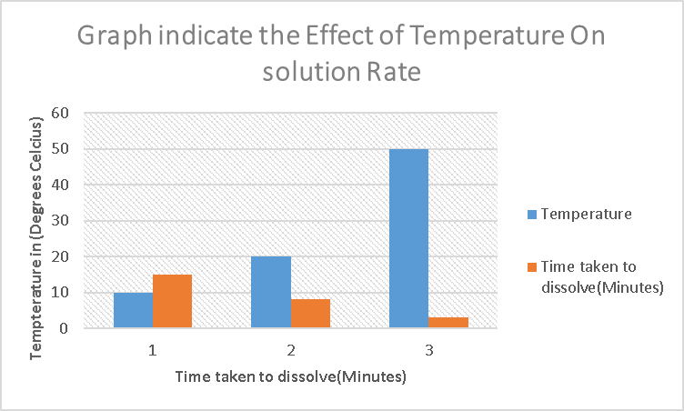
Interpret the Data: What does your data show? Be specific and descriptive.
In to the results recorded, the graph above indicate that, when temperatures are low, it takes much longer for solution to dissolve compared to when the temperatures are high. This proves my hypothesis that, high temperatures increase or speed rate of dissolving.
Conclusion: Did the results of your experiment validate your hypothesis? YES, the results validated my Hypothesis. Increased temperatures increases solution rate of dissolving.
What other variables might you test that would affect the solution rate of Alka-Seltzer®?
Size of the Alka-Seltzer particle
Application:
For various solids such as sugar and salt, which can dissolved in liquid water, their solubility rises with temperature.

Adapted from https://www.shsu.edu/academics/agricultural-sciences-and-engineering-technology/documents/HypothisisWorksheetDay2.pdf. Date and time accessed: 6/14/2021 11:09 AM CC BY Veronica Amaku.

